ToDA Recorder Kit:

Raspberry Pi 4B + AudioMoth + GPS/PPS

Goal
High-precision, PPS-disciplined audio recordings so multiple nodes can be used for Time-Difference-of-Arrival (TDoA) analysis.

What TDoA Provides in NFC Work
- Bearing (direction of flight)
  - With at least two synchronized recorders, the time difference between when a call hits each recorder lets you calculate an angle of arrival.
  - Example: If Recorder A hears a call 1.2 ms before Recorder B, geometry tells you the sound came from closer to A’s side.
- Position (location in 2D or 3D)
  - With three or more recorders at known positions (triangulation), you can solve for the bird’s approximate position in 2D.
  - With four or more, you can estimate altitude as well (3D fix).
- Flight Path
  - By tracking successive calls (most species call in series), you can reconstruct the direction and trajectory of the bird over time.
- Altitude Estimation
  - Especially valuable for migration research. TDoA gives you altitude within tens of meters, depending on spacing and timing precision.

Limits / Requirements
- Precise synchronization (GPS PPS) is critical — you need nanosecond accuracy.
- Array geometry matters: nodes spread ~500–1000 m apart give usable precision for flight paths.
- Environment: echoes, wind, and multiple birds can complicate cross-correlation.
- Species call rate: better for species that call frequently (e.g., thrushes) than for species with sparse calls.
- Doppler Shifts: are recorded, but they’re very small and generally ignored in nocturnal flight call and TDoA work. The main information used for trajectory comes from arrival times, not Doppler frequency shifts. But in practice, NFC studies do not use Doppler because:
  - The shift is small compared to species-to-species frequency variation.
  - It’s masked by call variability, background noise, and microphone response.
  - Cross-correlation for TDoA depends on timing, not frequency shifts.
- Raspberry Pi internal clock (no PPS, no NTP)
  - The Pi 4 has a basic crystal oscillator, not temperature-compensated.
  - Drift: typically 20–100 parts per million (ppm), depending on temperature.
  - That’s 1.7–8.6 seconds per day of clock error.
  - Or ~1 ms of error builds up every 10–50 seconds.
  - For TDoA, that’s catastrophic — two Pis would be out of sync by tens of milliseconds in just minutes.

Why
- Two or more, preferabbly three + of these kits will faclitatePPS (Pulse-Per-Second) ties the Pi’s clock to GPS at the integer-second boundary.
- Chrony disciplines system time to GPS + PPS for sub-millisecond alignment.
- Recordings start on clean time boundaries; each file has accurate UTC metadata.

Bill of Materials (per node)
- Raspberry Pi 4B in fan-less metal case (avoid fan noise).
- microSD (≥32 GB, A1 or better).
- AudioMoth Microphone used as USB audio interface or high-quality USB mic (48 kHz capable).
- GPS module with PPS (e.g., u-blox NEO-6M / M8 series).
- Wires: PPS → Pi GPIO, GPS TX/RX → Pi UART, GND/VCC as required.
- Weatherproof enclosure (field) + 5 V power (battery/solar/AC).
- Optional: external GPS antenna; mast/magnetic mount.

Wiring (defaults shown; alternatives noted)
- PPS → GPIO4 (physical pin 7).
(Alt: use GPIO18 if you already wired it; adjust overlay.)
- GPS NMEA UART
GPS TX → GPIO15 (pin 10, Pi RX), GPS RX → GPIO14 (pin 8, Pi TX)
GND ↔ GND, 3.3/5 V per module spec.
- Audio: connect AudioMoth (USB) or your USB ADC/mic.

Pi OS configuration for GPS & PPS
Edit /boot/firmware/config.txt (Raspberry Pi OS) or /boot/firmware/usercfg.txt (Ubuntu for Pi):
- # PPS on GPIO4 (default in this kit)
- dtoverlay=pps-gpio,gpiopin=4

- # Use main UART for GPS, free it from Bluetooth
- enable_uart=1
- dtoverlay=disable-bt
(If you wired PPS to GPIO18, use: dtoverlay=pps-gpio,gpiopin=18.)
Reboot.
You should get:
- /dev/pps0 (kernel PPS)
- /dev/ttyAMA0 (GPS NMEA serial)

Software install
- sudo apt update
- sudo apt install -y gpsd gpsd-clients pps-tools chrony python3-pip

Bring up gpsd (test, then persist)
Test in foreground:
- sudo systemctl stop gpsd.socket gpsd.service
- sudo gpsd -N -n -D 2 /dev/ttyAMA0 /dev/pps0
- # Ctrl+C when you see NMEA sentences flowing

Make permanent:
- sudo sed -i 's|^DEVICES=.*|DEVICES="/dev/ttyAMA0 /dev/pps0"|' /etc/default/gpsd
- sudo systemctl enable --now gpsd.socket

Quick checks:
- cgps -s # satellites + fix?
- ppstest /dev/pps0 # 1 line per second with assert timestamps?
- source 0 - assert 1755378255.000703809, sequence: 110812 - clear 0.000000000, sequence:
- source 0 - assert 1755378256.000703004, sequence: 110813 - clear 0.000000000, sequence:
- source 0 - assert 1755378257.000703365, sequence: 110814 - clear 0.000000000, sequence: 0
- Each line is a 1 Hz pulse from the GPS. The timestamp is the kernel’s precise record of when the PPS arrived.

Chrony: discipline to PPS

Append to /etc/chrony/chrony.conf (keep your pool lines):
- # NMEA from gpsd via shared memory unit 0
- refclock SHM 0 offset 0.0 delay 0.2 refid GPS

- # Kernel PPS; lock to GPS and prefer it
- refclock PPS /dev/pps0 lock GPS refid PPS prefer

- # Step quickly at start if needed
- makestep 0.1 -1
Restart and verify:
- sudo systemctl restart chrony
- sleep 5
- chronyc sources -v # GPS + PPS visible; PPS becomes ^* after fix
- chronyc tracking
- timedatectl # System clock synchronized: yes
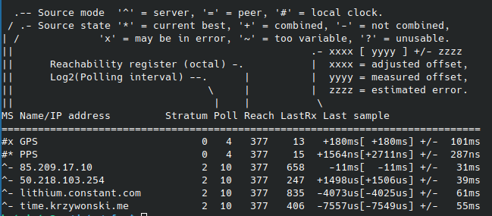Figure 1: chronyc sources -v

PPS Debug Tools
chronyc tracking
Expect: Reference ID PPS, Stratum 1, tiny Last/RMS offset
cgps -sch
Confirm gpsd has a 3D fix and valid UTC
sudo ppstest /dev/pps0
Should print one assert per second such as
chronyc sources -v
show the timing sources and associated drift

AudioMoth configuration (example)
Configured using the AudioMoth USB Microphone, https://www.openacousticdevices.info/usb-microphone. Other AudioMoth appimages needed is one to flash updates to the device and the other to set the time. At a future date the AudioMoth Recording device with a gps hat will be evaluated.
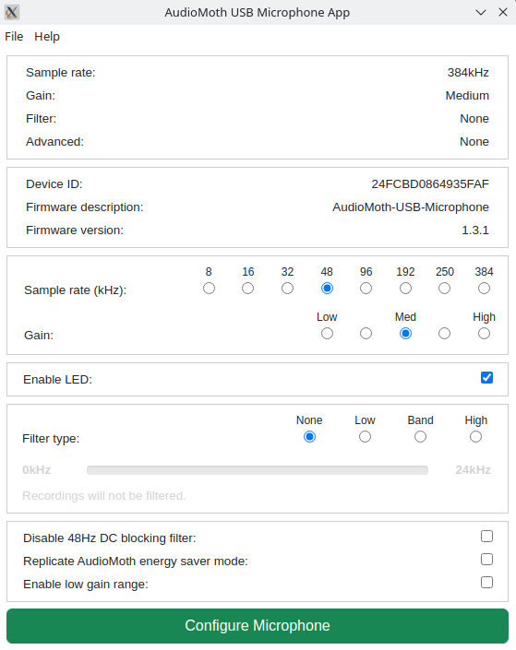
If using AudioMoth as the mic/ADC over USB, confirm it enumerates as an ALSA device:
- arecord -l
- be sure to set the microphone switch from USB/OFF to Default

Recorder behavior and schedule (requirements you set)
- 59 m 55 s WAV files, 5 s pause.
- Operates nightly 22:00–06:00 Eastern Time.
- UTC timestamped filenames and JSON sidecars with times.
- Align starts to PPS/next full second (and preferably the next full minute).

Python Synchronization Code

Minimal Python “kit” recorder requirements
Save as /home/pi/nfc_recorder.py. It:
- Waits for Chrony sync.
- Latches to next PPS and next full minute.
- Records 59:55 at 48 kHz via ALSA.
- Enforces 22:00–06:00 America/New_York.
- Emits .wav + .json with precise timestamps.

Core workflow
- Startup
  - Ensures /data/nfc directory exists.
  - Waits up to 120 s for chrony to report it’s synced.
  - Then waits for a PPS edge and sleeps until the next full UTC minute so every recording begins cleanly on a second boundary.
- Recording loop (22:00–06:00 local time)
  - If current time (America/New_York) is between 22:00 and 06:00 → call record_once().
  - Otherwise → just sleep until the next full minute.
- record_once()
  - Builds a UTC timestamped filename (NFC_YYYYMMDDTHHMMSSZ.wav).
  - Waits for the next PPS assert to minimize start jitter.
  - Calls arecord with 48 kHz, 16-bit, mono, for 3595 seconds (59m55s).
  - Creates a JSON sidecar with:
    - {
    - "file": "NFC_20250816T020000Z.wav",
    - "utc_start": "...",
    - "utc_end": "...",
    - "sample_rate_hz": 48000,
    - "bits": 16,
    - "channels": 1,
    - "duration_s": 3595,
    - "arecord_rc": 0
    - }
  - Signal handling
  - Catches SIGTERM and SIGINT to exit cleanly (important when running under systemd).

Points to double-check
- AUDIO_DEVICE = "hw:1,0" → may need to adjust if the AudioMoth (or USB ADC) enumerates differently. Run arecord -l to confirm.
- Time zone → Night window is checked in America/New_York. That covers DST correctly since it uses zoneinfo.
- PPS alignment → pps_wait_assert() uses ppstest output regex. Confirm ppstest /dev/pps0 works on your Pi.
  - If it’s noisy or slow, you could replace this with direct kernel timepps.h bindings for nanosecond accuracy, but ppstest is often good enough.
- Data path → All files go into /data/nfc. Make sure the Pi user has write permission there.
nfc_recorder.*.py is a seperate file
Make executable:
- mkdir -p /data/nfc
- sudo chown -R pi:pi /data
- chmod +x /home/pi/nfc_recorder.py

Systemd unit (auto-start, recover on crash)
/etc/systemd/system/nfc-recorder.service
- [Unit]
- Description=NFC nightly recorder (PPS-disciplined)
- After=network-online.target gpsd.socket chrony.service
- Wants=gpsd.socket chrony.service

- [Service]
- User=pi
- Group=pi
- Environment=PYTHONUNBUFFERED=1
- ExecStartPre=/usr/bin/chronyc waitsync 120
- ExecStart=/usr/bin/python3 /home/pi/nfc_recorder.py
- Restart=always
- RestartSec=10

- [Install]
- WantedBy=multi-user.target
Enable:
- sudo systemctl daemon-reload
- sudo systemctl enable --now nfc-recorder.service
- journalctl -u nfc-recorder -f

Verification checklist (bring-up)
- GPS fix: cgps -s shows 3D fix; UTC correct.
- PPS pulses: ppstest /dev/pps0 prints 1 Hz asserts.
- Chrony: chronyc sources -v shows PPS as ^*; chronyc tracking stable.
- Audio device: arecord -l shows your mic/AudioMoth.
- Trial file: run script once; check .wav header duration and .json times.
- Timing: consecutive files differ by exactly 60:00 wall time (59:55 + 5).

Data layout & sidecar schema
- /data/nfc/
- NFC_YYYYMMDDTHHMMSSZ.wav
- NFC_YYYYMMDDTHHMMSSZ.json
Sidecar JSON fields:
- {
- "file": "NFC_20250814T020000Z.wav",
- "utc_start": "2025-08-14T02:00:00Z",
- "utc_end": "2025-08-14T02:59:55Z",
- "sample_rate_hz": 48000,
- "bits": 16,
- "channels": 1,
- "duration_s": 3595,
- "arecord_rc": 0
- }

Multi-node deployment notes
- Use identical chrony config and PPS wiring on each node.
- Keep GPS antennas with good sky view; avoid RF/noise near mics.
- Maintain node IDs and store them in sidecars if desired (add "node_id": "Pi-N").
- For TDoA, ensure exact sample rate (48 kHz nominal; use the same ADC model across nodes to reduce ppm drift).

Troubleshooting
- No /dev/pps0 → check overlay pin number; confirm wiring; reboot.
- PPS not preferred → no GPS fix; wait longer; check antenna; verify lock GPS/prefer lines in chrony.
- arecord errors → wrong device index (AUDIO_DEVICE), permissions, or power noise on USB.
- Timing drift → confirm chronyc sources -v shows PPS as ^*; ensure node runs a while before recording so PLL settles.

Field checklist
- Weatherproof box closed; strain relief OK.
- GPS antenna mounted with sky view.
- Mic shielded from wind/rain; avoid structure-borne vibration.
- Pi time synced (timedatectl), PPS ticking, storage space ≥ 20 GB free.
- Short test recording before leaving site.

If you want this packaged as an image (preloaded OS + config + service), say the word and I’ll consolidate the files and paths exactly as above.

You said:
i'm trying to copy all that but only the first 2 pages?

ChatGPT said:
If you’re only getting the first couple of pages when trying to copy, it’s usually because the view window or export method is limiting what’s shown.
Here are three ways you can grab all of the ToDA kit content I just wrote:
- Expand and scroll before copying
  - Click into the text block, scroll all the way down so the browser actually loads everything, then select from top to bottom before copying.
- Use “Select All” instead of mouse drag
  - Click anywhere inside the text, then press Ctrl+A (Windows/Linux) or Cmd+A (Mac) to select the entire response, then copy with Ctrl+C or Cmd+C.
- Ask me to export it as a single plain text file
  - I can place the full kit write-up into a .txt so you can download it directly—no paging or scrolling limitations.
Do you want me to generate that plain text file of the full ToDA kit for you? That would guarantee you get every line.

ChatGPT can make mistakes. Check important info.

3-node, GPS-PPS–synced array

y (north)
^
|
C(xc,yc) •
\
\ Hyperbola for ΔtAC
\ (|S−A| − |S−C| = c·τAC)
\
\
• S(xs,ys) ← unknown call source
/
/
/ Hyperbola for ΔtBC
/ (|S−B| − |S−C| = c·τBC)
/
A(xa,ya) •-------------------------• B(xb,yb) → x (east)

Legend:
A, B, C = recorder nodes with GPS+PPS time sync
S = bird (call source) projection on the horizontal plane
c = speed of sound (≈ 343 m/s @ 20°C, dry air (need humidity compensation)
τij = TDoA (ti − tj), from cross-correlation of the two recordings

What the math is doing (2D)
Each TDoA gives you a branch of a hyperbola defined by the difference in distances to two foci (the two recorders). The source S is at the intersection of two hyperbolas:
- Positions of nodes (known): A=(xa,ya), B=(xb,yb), C=(xc,yc)
- Detection times (from PPS-disciplined clocks): tA, tB, tC
- TDoAs (from cross-correlation):
τAB = tA − tB, τAC = tA − tC, τBC = tB − tC
- Constraints (pick any two):
∥S−A∥−∥S−B∥∥S−A∥−∥S−C∥​=cτAB​=cτAC​​
Solve for S=(xs,ys) (e.g., nonlinear least-squares).
Altitude (3D): To solve (x,y,z) without assumptions, you need a 4th node. With 3 nodes you can:
- assume a nominal z (e.g., 300–700 m migration altitude) and solve for (x,y),
- or solve (x,y) and do a sensitivity sweep over plausible z to bracket altitude.

Practical Implementation Pipeline
- Tightly sync clocks
GPS NMEA + PPS → chrony; verify PPS is preferred (chronyc sources -v shows PPS as ^*).
- Detect the same call on all nodes
Band-pass filter around species band (e.g., thrush 2–8 kHz) and detect peaks.
- Cross-correlate waveforms to get TDoA
  - Use GCC-PHAT for robustness.
  - Refine to sub-sample accuracy (parabolic fit around peak).
  - Example: at 48 kHz, 1 sample ≈ 20.833 µs → path difference ≈ 7.15 mm; sub-sample fitting matters.
- Invert for position
  - Form two hyperbolic equations, solve (xs,ys) by nonlinear least squares (e.g., Levenberg–Marquardt).
  - Initialize with bearing from the largest-magnitude τ pair.
- Uncertainty
  - Propagate timing error σ(τ) (from correlation peak width + SNR) → σ(position).
  - Report ellipse of uncertainty; keep geometry well-conditioned (avoid nearly collinear A-B-C).

Rules of thumb (geometry & spacing)
- Baselines (node spacing) ~ 500–1000 m work well for NFC; larger baselines improve angular resolution but raise multipath/weather mismatch risk.
- Don’t put all three in a line; aim for a scalene triangle covering your region of interest.
- Height differences between nodes are usually small vs. altitude; okay to work in 2D and sweep z.

Tiny worked example (intuition)
- Baseline A–B = 800 m east-west, C is 500 m north of midpoint.
- Measured TDoAs: τAB = +1.2 ms, τAC = +0.4 ms.
- Convert to path-length diffs: ΔAB = c·τAB ≈ 0.343 m/ms × 1.2 ms ≈ 0.412 m, ΔAC ≈ 0.137 m.
- Intersect the two hyperbolas → S lies slightly closer to A than B, and slightly closer to A than C, giving a bearing roughly from the south-east toward A. (A solver gives exact coordinates.)

Implementation notes you can drop in
- Cross-correlation (Python): scipy.signal.fftconvolve + PHAT weighting; parabolic interpolation for sub-sample τ.
- Solver: scipy.optimize.least_squares minimizing residuals of the two hyperbolic equations.
- Speed of sound c: Use temp/humidity to adjust (e.g., c ≈ 331.3 + 0.606·T°C m/s).
- Clock sanity: Log PPS phase and chrony tracking; discard calls when nodes are not in sync.
- Quality filter: Require consistent τ across all pairs (AB, AC, BC) within a small residual (closure test).

Images:


